Event Details

- Title of Event: Career Guidance Program on Critical Skill Shortages for Bio Sciences Professionals: Kick Starting an Accelerating Future
- Date: Monday, October 7, 2024
- Time: 11:00 AM
- Venue: TB 99 Hall, Union Christian College Aluva
- Organized by: Department of Zoology and Department of Botany
- Participants/Audience: Students

Objective

The purpose of this event was to provide career guidance to students, highlighting critical skill shortages in the bio sciences industry and exploring various career options.
Event Summary

The career guidance program was conducted by Mr. Sony Akkara, an international certified career coach and founder/executive director of Easylink Academy. Mr. Akara shared his expertise on various career paths for biotechnology, zoology, and bioinformatics graduates, including:

- IT industry
- Data science
- Medical coding
- Healthcare informatics
- Food industry

He drew from his international experiences, explaining the critical skill shortages in different countries. Mr. Akara provided a comprehensive overview of each course, emphasizing the importance of acquiring relevant skills to capitalize on emerging opportunities.
Highlights

- Expert insights from Mr. Soni Akara, international certified career coach
- Exploration of diverse career options in bio sciences
- Discussion on critical skill shortages globally
- Interactive session with students
Outcome/Impact

The program aimed to:

- Enhance students' awareness of career opportunities in bio sciences
- Equip students with knowledge of critical skill shortages
- Inspire students to pursue emerging fields
Feedback

Students praised Mr. Akkara's engaging presentation and valuable advice. Many expressed gratitude for the exposure to various career paths and global perspectives.

Photos/Videos

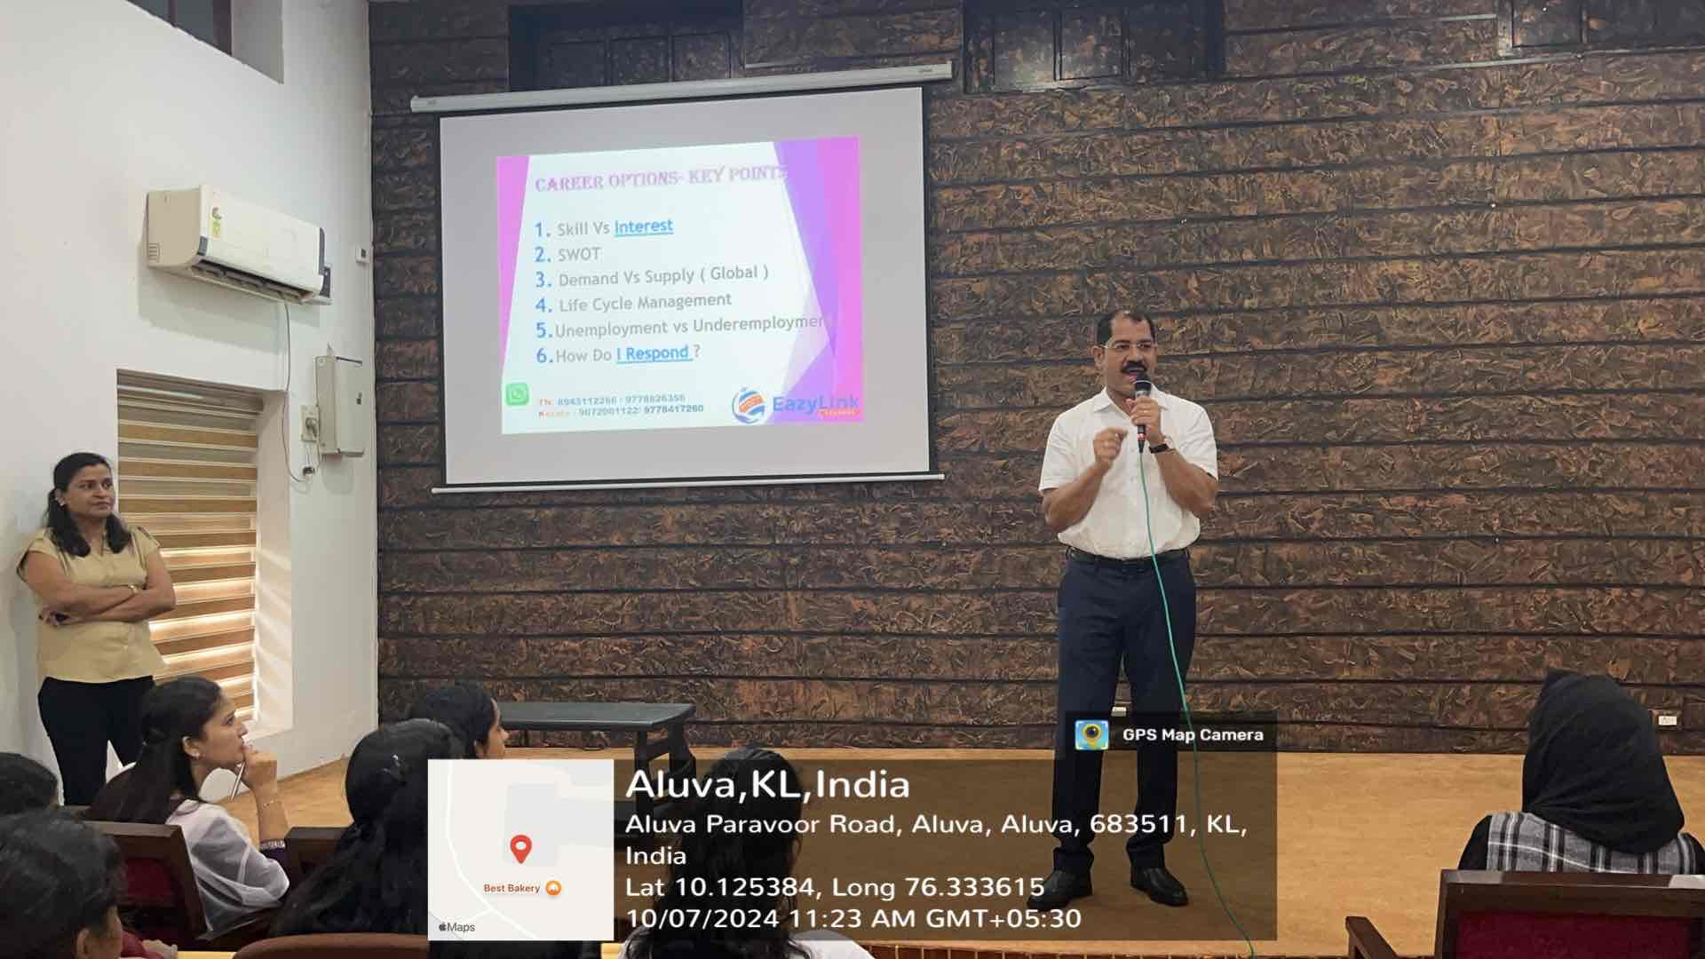
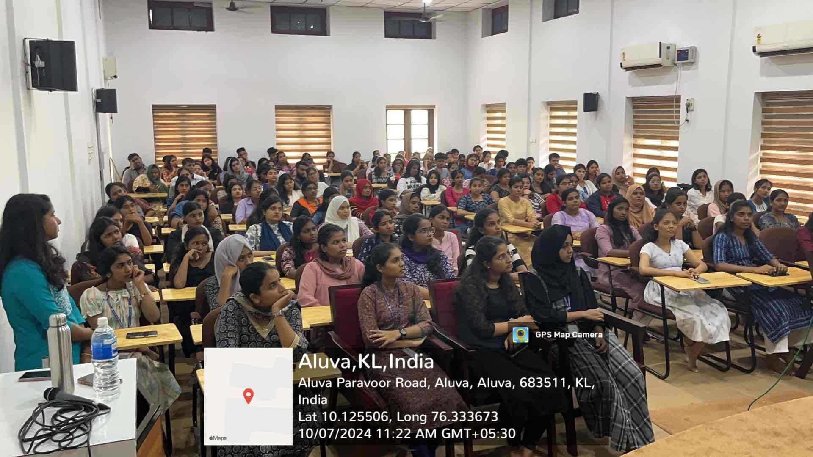

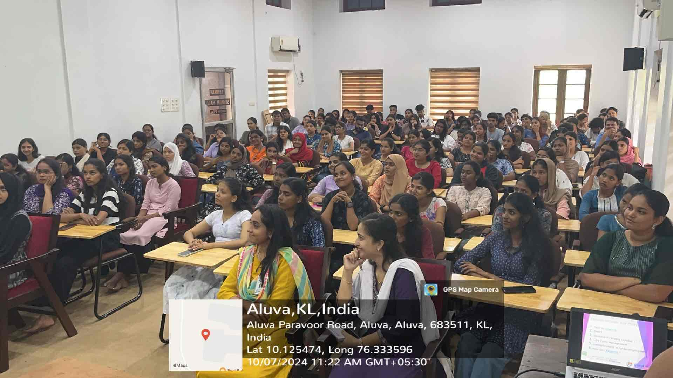
Future Recommendations

- Conduct regular career guidance sessions with industry experts
- Invite alumni to share their experiences
- Organize workshops on skill development and entrepreneurship

Acknowledgements

The Department of Zoology and Botany, Union Christian College Alua, expresses gratitude to Mr. Sony Akkara for sharing his expertise and inspiring students.

Report Prepared by: [Your Name]

